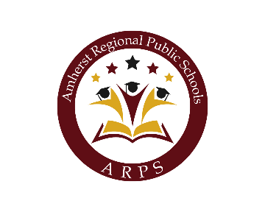

Thursday, June 9, 2022
Joint Amherst, Pelham & Amherst-Pelham Regional School Committee

6:30 PM
Virtual Meeting
This meeting will be shown via live-stream on Amherst Media (Channel 15)
All times listed below are approximate
1. Meeting Opening/Joint Topics
A. Call to Order Amherst School Committee - 6:30 p.m.
B. Call to Order the Pelham School Committee - 6:31 p.m.
C. Call to Order the Regional School Committee - 6:32 p.m.
D. Approval of Minutes - 6:32 p.m.
View Minutes for Apr 26, 2022 - Joint Amherst & Pelham School Committee
E. Artifact Orientation - 6:35 p.m.
File Attachments
Artifact Document 2022 (final).pdf (248 KB)
F. Adjourn Amherst School Committee - 6:50 p.m.
G. Adjourn the Pelham School Committee 6:52 p.m.
2. Region Topics Only
A. Approval of Minutes - 6:53 p.m.
View Minutes for May 24, 2022 - Amherst-Pelham Regional School Committee
B. Public Comments - 6:55 p.m.
Members of the public who would like to submit public comments to the Committee can do so by sending an email message, or an audio of their public comments to School Committee Public Comment at SCPublicComment@arps.org or by leaving a voicemail at 413-362-1891. Regardless of method, the comments need to be submitted by 3:00 PM on Thursday, June 9, 2022 with the Subject listed as "Public Comment". The message should also include their full name and town of residence. Public comments will be either shown on the screen for viewing or played at the meeting for no more than 3 minutes per comment. All public comments submitted will become part of the public record.
C. Superintendent's Update - 7:05 p.m.
D. Chair's Update - 7:10 p.m.
E. School Committee Announcements - 7:15 p.m.
3. New and Continuing Business
A. Secondary Math Update
File Attachments
Update on Secondary Math (1).pdf (27 KB)
B. Potential Change in Special Education Legal Counsel
File Attachments
Legal memo (1).pdf (31 KB)
NMJ and Amherst-Pelham (1).pdf (16,358 KB)
D. Policy Subcommittee Update
View Minutes for Mar 23, 2022 - Policy Subcommittee
File Attachments
DRAFT Policy Subcommittee minutes - Monday, May 23, 2022 (1).pdf (56 KB)
E. End of Fiscal Year
This topic will also include discussion around support for Theatre Arts
F. Future Agenda Planning
G. Warrant Report
H. Accept Gifts
4. Adjournment
A. Convene into Executive Session
Motion to convene into Executive Session
The Regional School Committee will now consider entering executive session in accordance with the Open Meeting Law, M.G.L., c. 30A, section 21(a), to conduct collective bargaining sessions, and to discuss strategy with respect to collective bargaining or litigation of APEA and APAA if an open meeting may have a detrimental effect on the bargaining or litigating position of the public body and the chair so declares; and to approve minutes in accordance with the Open Meeting Law, M.G.L., c. 30A, section 22, with no intention of returning to open session.

