Essex Council on Aging Minutes
March 1, 2022
6 pm meeting

Meeting Facilitator: Kay Joseph

Attended: Kristin Crockett, Dick Denton, Beverly Dolinsky, Gil Frieden (board member elect), Millie Hamlen, Ralph Hawley, Kay Joseph, Tess Leary, Susan Parady,

Absent: Dawn Burnham, Sue Lufkin, Mary Wilhelm,

Call to Order – 6:04pm (9 yes, 0 no, 0 abstain)

- Secretary’s Report (approval of minutes:
  - February minutes were reviewed and approved (9 yes, 0 no, 0 abstain)
- The Treasurer’s Report
  - Town reporting of our January financial activity was received after our February 1st Board meeting and is as follows:
Operating Budget at 1/31/2022
Beginning balance $102,623.00 comprised of $99,783.00 budgeted for fiscal 2022 and another $2,840.00 retained from 2021 Flooring Contract. Fall Town Meeting allocated $11,000 additionally for a new furnace; total funds available $113,623.00. “Budgeted Balances” remaining after seven months operations are $48,611.07. Flooring Contract and Furnace Allocated funds, which are in addition to $48,611.07, will be deducted at the appropriate time. We understand one additional furnace part is needed prior to invoicing. Neither Flooring or Furnace funds is not included in budget discussions below.
Less than monthly proportional spending is reflected in four accounts. More than monthly proportional spending exists in one. We have a modest negative balance in our $7500 COA account. This account covers a wide variety of charges including office supplies, cleaning, exercise consultants, and postage. In other years, we have been able to allocate some of these expenses to our Formula Grant, prior to receiving it. Not so this year. After we receive it, we hope to use it for some “COA Account” expenses.
We have more than monthly proportional positive balances in four accounts. Building Maintenance was budgeted $14,000, based on historical experiences; $8500 remains unspent. Transportation was budgeted $6000, largely as a safety amount as we transitioned to CATA and Town funding of transportation; $5352 remains unspent. Utilities account reflects 38% usage during 58% of our fiscal year due to other than monthly billing cycles established by the Town. We expect most of the remaining $4000, of original $6500, to be spent. We significantly increased part time Clerical to $11,768; 72% or $8400 remains unspent due to strong volunteer support this year.
Our two professional staff accounts reflect near proportional monthly expenses and likewise proportional remaining balances.
Please bring your questions to our March 1st Board Meeting. With February ending the immediately preceding Monday, I am quite uncertain about having February expense data to present the next day.
Formula Grant: No availability at 1/31/2022
Gift Fund: Beginning balance $6940.15. $108.00 added,
$657.92 subtracted.
Ending balance 1/31/2022: $6390.23.The Director’s Report:
  - Monthly Statistics
    - Statistics for January was not yet available. Kristin will report January Statistics in February
    - Kristin reminded board members to remember to sign in and out when at the building. The sign out data is important for the tallying of accurate statistics. If board members are doing work for the board and not at the center, Kristin would like the board members to email total hours of volunteer time each month.
  - Formula Grant
    - Formula grant funds are expected soon.
    - Annual Report was submitted 1/31
      - Kristin noted that the Center needs to purchase a computer for the clerk. The older computer used by the director is not functioning well, and the clerk is using her own computer.
  - Programming
    - Monthly Programming Meeting occurs first Thursday of each month at 9:30am.
    - Speaker Series: The Center has scheduled a monthly speaker “Planning Your Next Steps” series of particular interest to ‘junior’ seniors. Specific topics include a two part Housing series, decluttering, legal, health and wellness, end-of-life planning, Medicare, Social Security, and Travel and leisure. The meetings will be the third Tuesday of each month at 7pm at the Town Hall Auditorium.
    - Beeyonder – The Center has contracted to offer a series of live virtual guided tours. The Center will trial this programming for four months. Participants can access the tours from home, or come to the Center.
    - The Center is now offering a free monthly art class on Wednesday’s and Friday’s.
    - Virtual Senior Center – Every Body Fit will be offered on channel 67. The “Valentine’s day show: Jerry and Mabel” sponsored by the Essex COA will also be available on Channel 67.
    - Older Americans Month is May. Theme is “Age My Way”. The Center will be looking at different events and an Open House in May. Please email Kristin or Tess with suggestions.
- Meals Update:
  - The Center has a new partnership with “Root” in Salem via Senior Care. Root is a nonprofit teaching young adults job readiness skills. The Center heard positive feedback for the first “Root” meal. The meal will be a cold meal, needing to be warmed at home.
- Newsletter Update:
  - Newsletters were mailed out earlier, and uploaded to the town’s website all before the beginning of the new month. It was also emailed via Mail Chimp to 85 email addresses. Kristin is working on building a landing page under mail chimp and will work with Brendhan to embed a sign-up for the digital newsletter
- Facilities update:
  - CO Detectors were replaced in the front vestibule and basement.
  - Shelves were installed in the basement to help with storage for Friends of the COA items
  - Covid-19 related Update
    - Free COVID-19 at-home tests are now available via the Federal Government. Individuals can order the tests going onto the following website: https://www.covidtests.gov/https://www.covidtests.gov/. Individuals can also call 1-800-232-0233. 4 tests are available per residential address. This is causing some problems with Story Street Apartments, Chebacco Terrace, some homes classified as business, and mixed residential. The COA will help those without computer access.
    - Non-Medicare insurance will pay for up to 8 tests per person per month on the plan. Original Medicare will not cover at-home COVID tests.
    - Under the State contract the Center can purchase COVID tests through the town. Some COAs are offering tests. Essex DOH expressed they do not recommend purchasing tests.
  - Strategic Plan Update
    - Goal #1: Collaborate with community to identify unmet needs.
      - Liaisons are in place
      - COA director is meeting with neighboring COAs monthly.
      - Previously discussed survey will be going out soon. Volunteers are needed to help stuff envelopes and prep for mailing.
      - In our last newsletter we have asked folks to re-register with the Center
    - Goal #2: Create awareness of the needs of our senior residents and available support services.
      - Anyone who completes a new registration with phone and/or email will be entered into a drawing for gift cards. Email has been sent out to residents. The Center is looking for a volunteer to help update email addresses on Mail Chimp.
    - Goal #3: Develop programs and services that promotes well-being and maintains independence.
      - Speaker Series promoting independence for junior seniors has been developed.
      - Kristin has applied for SMP training.
      - Staff will participate in State mandated LGBT Issues in Aging course.
    - Goal #4: Provide an inclusive environment where all individuals can socialize, build relationships, and receive information.
      - New events and programs are being looked at and planned.

- By Law Revision Review – Susan Lufkin
  - The subcommittee is working on adjusting the By-Laws and hope to send a draft to the Town Administrator within the month to ensure suggested changes are legal. The subcommittee reviewed over 10 city and towns by-laws as a basis to adjust the Essex COA by-laws. After the Town Administrator’s review, it will then be sent to the Board for review. It is estimated the board will receive the draft in April.

- 2022 Budget Review (vote required) – Kristin Crockett
  - The preliminary budget has been developed and sent to the Town Administrator for review. The budget was submitted to the Town first in order to meet the Town deadline knowing the board would not review it until this meeting.

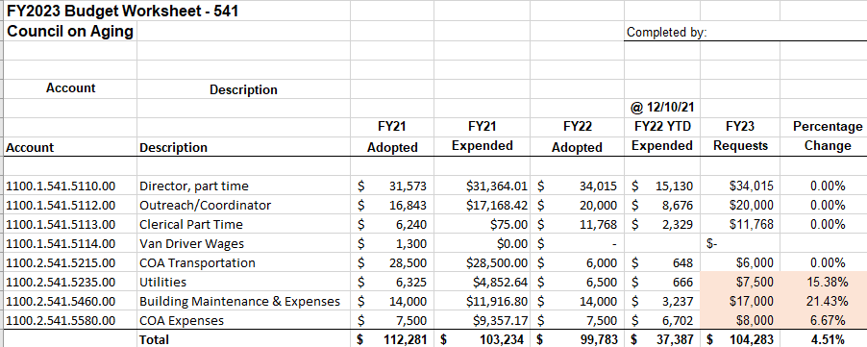
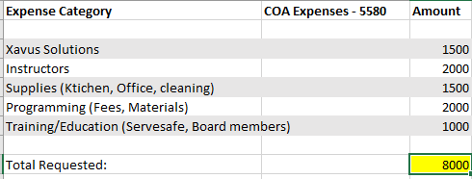
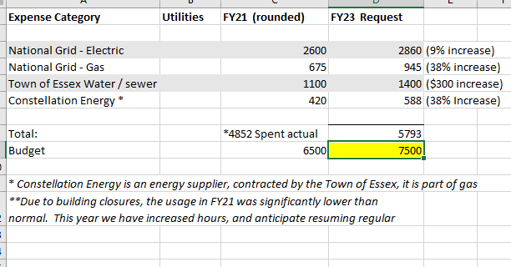
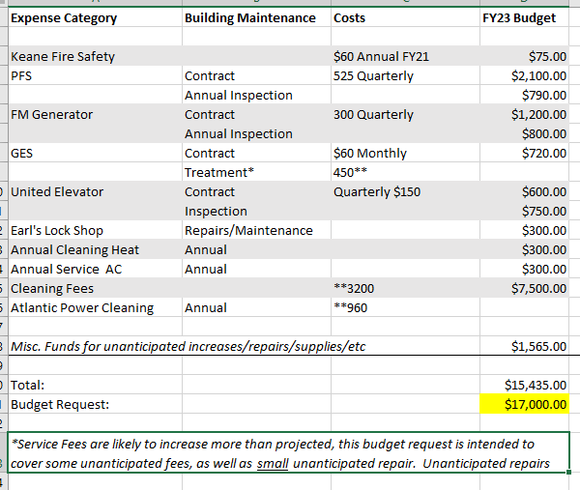

  - It was noted that programming funds are not included in this budget. Programming is supported via the Formula grant, Friends of Essex Council on Aging, and Gift fund.
  - The Board reviewed and approved the FY2022 budget (8 yes, 0 no, 1 abstain)

- Board Member Liaison Update
  - Library – The Center is we are sharing information about programs and book clubs; the library will try to have book club titles available for borrowing and the Friends will continue to support the purchase of additional books for borrowing from the COA.
  - Board of health – mask mandate is still in effect. COVID numbers are down but still high. The Board recommended cancelling the blood pressure clinic due to forecasted inclement weather.

- Friends of Essex Council on Aging Update:
  - Valentines Dinner will be on the 10th . 70 have signed up. Scouts will be helping to deliver the meals. The 3rd grade Essex Elementary Class will again include written valentine notes.
- New Issues
  - Treasurer asked the Friends to consider funding the new marketing initiatives of an expanded newsletter the given the MCOA Service grant proposal was declined. Dick and Kristin will put together a modified proposal to put forward to board and have the Friends consider funding the request.
  - Reopening Center: The board discussed the possibility of reopening the center given COVID rates are declining.
    - Tess noted our busiest program is already in the building (mobile market).
    - KN95 masks are available for use. Board recommended, but are not requiring, individuals in Center use N95 masks. Cloth masks will not be allowed.
    - To maintain public health standards, eating and drinking cannot occur within a public building. Therefore activities with food/drink cannot happen.
    - Kristin emphasized the need to sign in and out as the attendance program has a covid tracker and the Center can notify individuals who may have been in close contact with a positive case.
    - Motion was made to reopen the Center with Center participants required to wear a mask (no cloth masks allowed) (9 yes, 0 no).
  - Noted Governor Baker in his 2022 State of the Commonwealth speech has proposed a decrease on property taxes for senior citizens. The Board will send a letter to Governor Baker, Senator Tarr and Representative Ann-Margaret Ferrante thanking them for this initiative..

- 7:35 Motion to adjourn the meeting. (9 yes, 0 no)

Minutes submitted by Beverly Dolinsky

