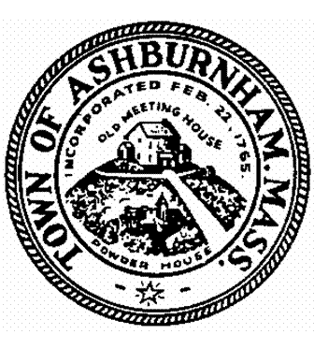
Animal Control
Board of Health
Building Commission
Conservation Commission
Council on Aging
Cultural Council
Electrical Inspector
Gas & Plumbing Inspector
Historical Commission
Municipal Planning
Parks & Recreation
Planning Board
Zoning Board of Appeals

PHONE: (978)-827-4100
FAX: (978) 827-4105

Board of Selectmen
Extension 109
Town Administrator
Extension 109
Town Accountant
Extension 120
Town Clerk
Extension 114
Tax Collector
Extension 113
Treasurer
Extension 112 or 110
Board of Assessors
Extension 111
Land Use Office
Extension 117
Planning Board
Extension 121
Conservation Commission
Extension 115
TOWN OF ASHBURNHAM
Town Hall, 32 Main Street
Ashburnham, Massachusetts 01430

COA Board Meeting Minutes 4/11/2022
Present- Marcy Corby, Ginny Driscoll (Secretary), Elle Baker (Board Chair), Jan Robbins (Director) and Paula Gorrell (Not in attendance: Shirley Stevens & Gloria Jean Lorion)
Meeting opened @ 12:02pm
Minutes read from 11/15/2021 approved by Marcy, seconded by Paula.
Our new member elect, Dick Nyman, passed away a few weeks ago.
Silver Sneakers has resumed on Thursdays for April and May (funds will be drawn from COA Donation account) and line dancing has resumed both Mondays and Thursdays.
Discussion regarding newsletter publications changing to new owners. Will give them 6 months with no contract before a decision will be made to continue with them or move to a larger publication company.
Our Christmas dinner will resume this year. Paula will ask David Mei about having it at the Turnpike
Rod and Gun Club in town with the Savory Skillet preparing the food. Possible dates for the dinner are
December 8 or December 15.
Anne Erickson (former craft teacher at the center) showed interest in helping to form a friend’s group.
Ashburnham Parks and Recs is now Ashburnham Community Events and Playground Committee.
Downtown Days, due to covid, is not happening this year.
Celebrate Ashburnham Day is going to be on Sept.24 from 10-5. It will be a street fair and the streets
downtown will be blocked off from traffic from Main Street to Pleasant and Water Streets. Local
businesses and home businesses will be promoted and set up on the roads.
Maybe a concert could be held after 3 pm to end the day.
COA meeting will be the second Monday of the month at noon in April, May, June, Sept. Oct. and Nov.
There are a lot of items (bingo machine, 2 large printers, chairs, etc.) at the center that are no longer needed or belong to other departments. The Select board has been made aware of these items that are taking up needed space.
There was discussion regarding the acoustics issue at the senior center.
May 9 is the next COA Board meeting.
Motion to adjourn by Marcy, seconded by Paula.
Meeting adjourned at 1:20pm

Respectfully Submitted,
Ginny Driscoll, Secretary

